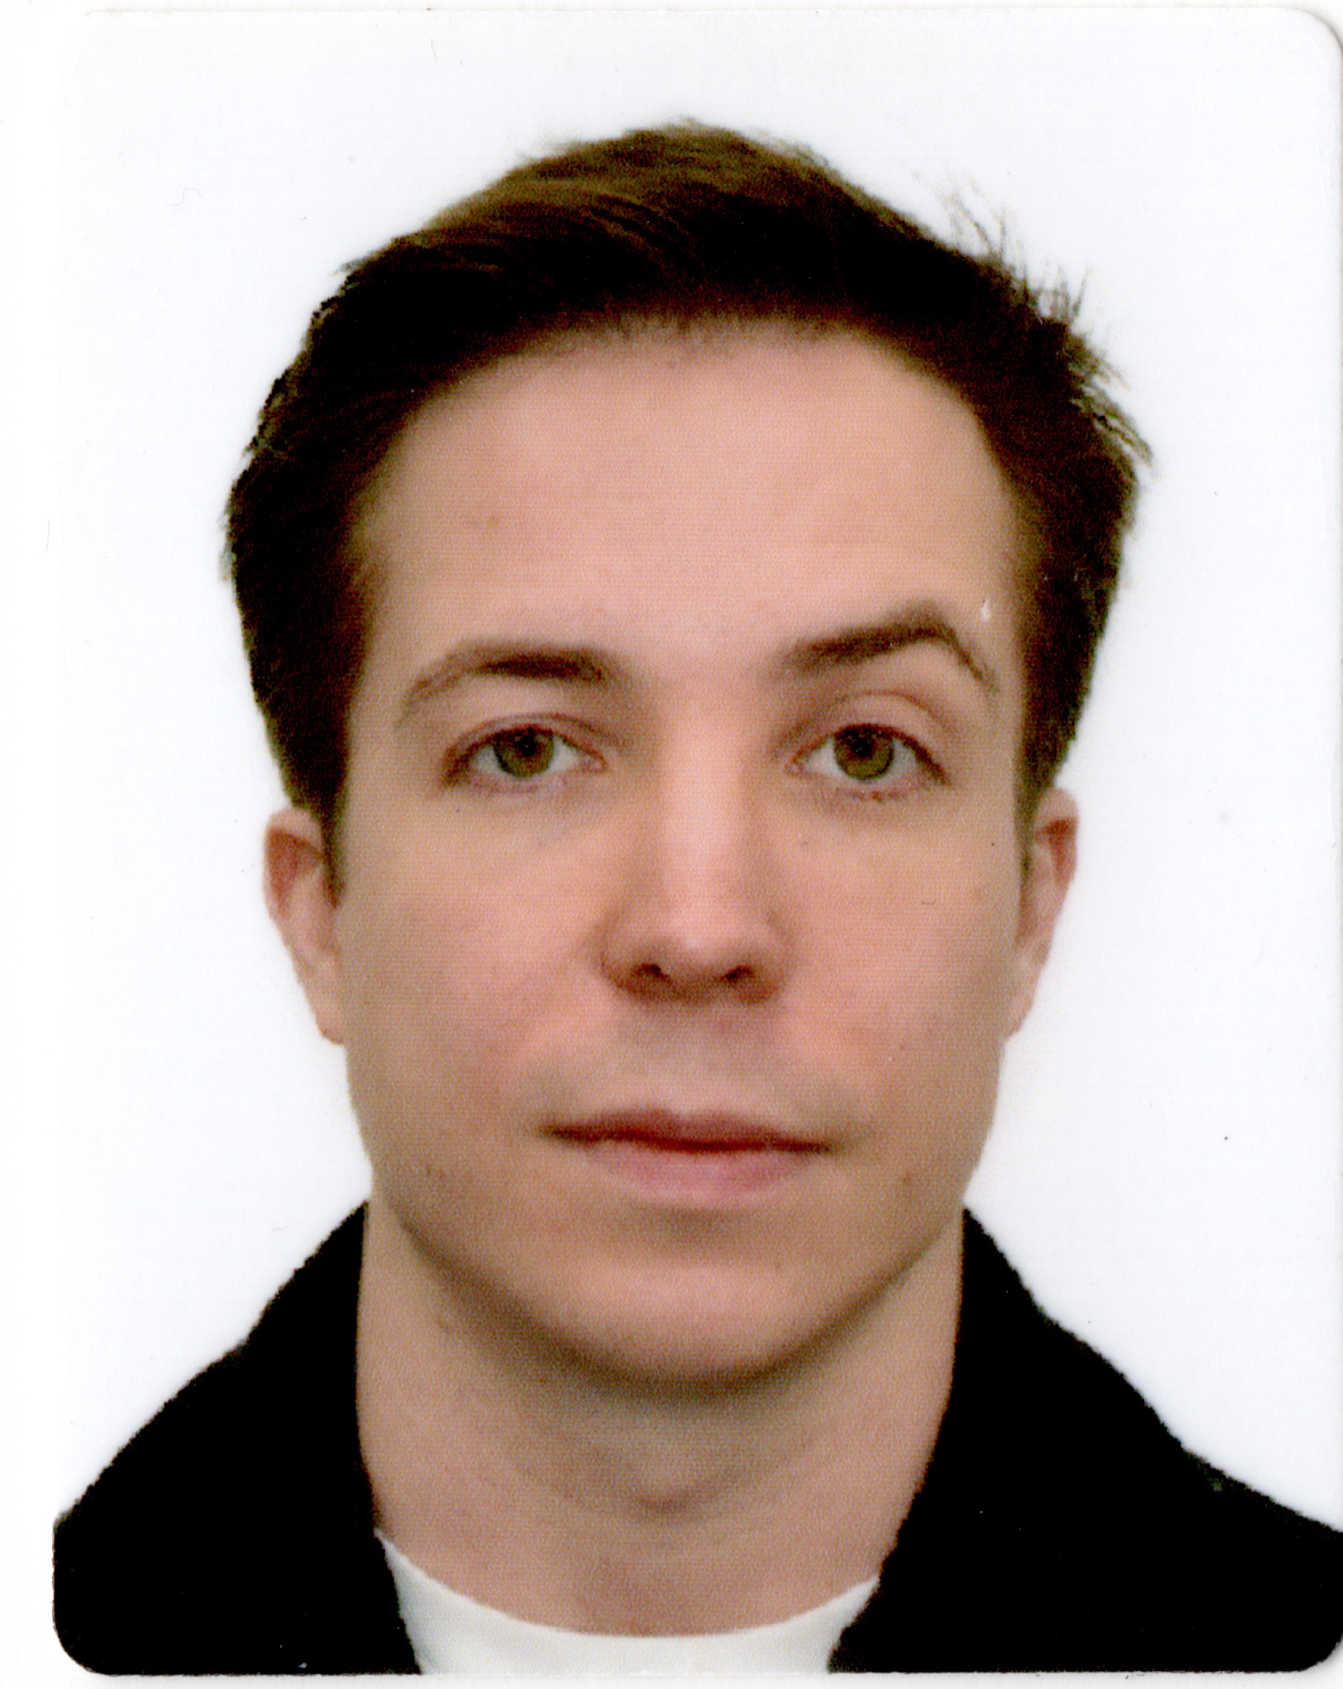

Name: Andrew Rowan

Email: ap.rowan@outlook.com

Phone: +44 7453108181

Address: 6/40 Evans St, Balmain 2041

DOB: 15th December 1988

Nationality: Australian and British dual passport holder

225 Jewellery Exchange Ltd., London W1K 5LP U.K.
__________________________________________________________________________
Luxury antique jewellery retailer in London with an international clientele.

March 2020 – January 2021.

Customer Service Co-ordinator:
- Assisted with sales in-store and online.
- Coordinated international shipments and repairs’ processes.

Marubeni Europe, London, England.
_________________________________________________________________________
A major Japanese trading and investment business conglomerate.

December 2019 – February 2020.

Supply Chain Administrator:
- Managing the procurement of frozen seafood from Asia and coordination of delivery to European customers.
- Liaising with freight forwarders to ensure that all customs documentation is presented correctly and on time.
- Using SAP to create purchase/sales contracts and to process invoices.

Richemont Group, London, England.
_________________________________________________________________________
The Richemont Group owns luxury brands including Cartier and Van Cleef & Arpels.

October 2019 – November 2019.

Supply Chain Administrator, luxury goods:
- Managing the inventory goods flow between Richemont UK’s central storage hub and boutiques in the UK and abroad.
- Receiving in, performing QC’s on and booking stock into SAP.
- Liaising with freight forwarders to ensure all shipments are completed on time.

JX Nippon Oil and Energy Europe Limited, London, England.
_________________________________________________________________________
The largest motor oil company in Japan.

May 2018 – October 2019.

Assistant Manager OEM Team, SCM Planning Group, Lubricants Division:
- Acting as the main point of contact for FUCHS Lubricants, JX Nippon Oils only UK based blending plant.
- Co-ordinating deliveries from FUCHS Lubricants to Toyota factories in Derby, Deeside, France, Turkey and the Czech Republic, as well as Honda factories in Swindon and Ghent.
- Managing raw material procurement for FUCHS Lubricants JX product line by communicating with global suppliers and freight forwarders arranging shipments based on incoterms and lead times.
- Assisting account managers with new product launch by sourcing additives, coordinating test blending and troubleshooting production concerns.
- Leading a monthly meeting with FUCHS staff to address any customer complaints, delivery delays and check product implementation progress.
- Accurate input and invoicing of all raw material and customer orders in SAP.

SHARP Business Systems UK Plc, Uxbridge, England.
_________________________________________________________________________
A leading manufacturer of digital information technologies.

December 2017 – May 2018.

Supply Chain Co-ordinator:
- Dealing with customer enquiries regarding stock availability, delivery, price and product specification.
- Booking arrangements and load planning of orders as required to fill customer needs.
- Accurate input of customer orders into SAP.

SUMCO (Sumitomo Mitsubishi Silicon Corporation), London, England.
________________________________________________________________________
The second largest silicon wafer manufacturer in the world, with 30% market share.

July 2017 – November 2017.

Sales Support Officer:
- The primary Sales Support Officer for Bosch (Robert Bosch GmbH) and two ST Microelectronics sites: Catania (Italy) and Rousset (France).
- Planning and controlling the movement of goods from SUMCO factories in Asia and the USA to European customers by liaising with freight forwarders.
- Assisting Account Managers in troubleshooting customer concerns.
- Using SAP to create consumption forecasts and reports, manage shipping and delivery schedules and to process invoices and customer purchase orders.

Altia Central, Nagoya, Japan.
_________________________________________________________________________
Suppliers of ALT’s to government schools in Japan.

May 2016 – May 2017.

English Language Teacher:
- Assistant English language teacher at two high schools in Gifu, Japan

The Ingenium Group Inc., Tokyo, Japan.
________________________________________________________________________
Specialist recruitment agency for bilingual professionals to senior and mid-level executive positions.

July 2015 – April 2016.

Associate:
- Recruiting within the digital marketing sector, working with a U.S. based [Pre-IPO, Cloud, SaaS] start-up company to assist in building out their office in 3 regions across APAC : Tokyo, Australia and Singapore.
- Source and screen candidates via LinkedIn and via cold calling.
- Secured my first placement within one month, bringing in a ¥2.5M fee.

East West Consulting K.K., Tokyo, Japan.
__________________________________________________________________________
The largest executive search and recruitment agency in Tokyo.

June 2014 – June 2015.

Associate:
- Recruiting within the Semiconductor and IT sector, worked on SaaS and Cloud solution projects.
- Source and screen candidates via LinkedIn and via cold calling.
- Successfully sourced over 120 applicable candidates.

Gaba Corporation, Tokyo, Japan.
___________________________________________________________________________
Provider of high quality English language instruction to Japanese clients on a one-to-one basis.

July 2013 – May 2014.

English teacher:
- 1-to-1 English language teacher.

225 Jewellery Exchange Ltd., London W1K 5LP U.K.
__________________________________________________________________________
Luxury antique jewellery retailer in London with an international clientele.

September 2012 – June 2013.

Customer Service Co-ordinator:
- Assisted with sales in-store and abroad on sales trips to New York, Los Angeles and Tokyo.
- Customers included Ralph Lauren’s flagship store on Madison Avenue, New York.
- Developed the company’s website which now has a half million sterling annual turnover.

Riedel Resources Ltd., Perth, Australia.
___________________________________________________________________________Mineral exploration company focused on precious and base metal mineral projects in Western Australia.

March 2012 – August 2012.

Geological Field Assistant:
- Collected soil samples on 3-week work rotas in the outback.
- Assisted in analysis of samples when back in Perth.

Global Geophysical Services, Crew 665, Kurdistan, Iraq.
__________________________________________________________________________Worldwide seismic exploration company for the oil and gas industries.

July 2011 – January 2012.

Junior Observer:
- Management and co-ordination of crew of 12 Kurdish line workers.
- Assisted in supervising drilling operations ensuring workers followed correct health and safety procedures.

EDUCATION:

- University of Sussex, Lewes, U.K. Bachelor of Arts, Geography, (2008 – 2011)
Grade : 2.1

OTHER:

- International driving licence.
- Level 1 Excel Certified

LANGUAGES:
- English : Native speaker
- Japanese : Level N3

REFEREES :

- Rikke Hansen, Operations Manager, Richemont Group.
- Masahiro Kawahata: Supply Chain & Planning Manager, JX Nippon Oil & Energy Europe Limited, masahiro.kawahata@jxeurope.com
- Kamran Saeed: OEM Group Manager, Lubricants Division, JX Nippon Oil & Energy Europe Limited, kamran.saeed@jxeurope.com.
- Kristie Scott-Woodham: UK Supply Chain Manager, Sharp Business Systems
UK, kristie.scott-woodham@sharp.eu
- Akihiko Kuwahara: General Manager, Finance and Administration,
SUMCO Europe Sales PLC
- Per Knudsen, Managing Director, Ingenium Tokyo.
- Jackie Murphy: former Geologist Supervisor, Riedel Resources Perth
- Robin Guscette: Operations Manager EAME, Global Geophysical Services

